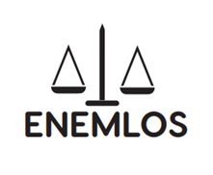
LEGAL CLINICS IN SERVICE OF VULNERABLE GROUPS: ENHANCING THE EMPLOYABILITY OF LAW STUDENTS THROUGH PRACTICAL EDUCATION
ENEMLOS

Report for the 3rd day training in the framework of ENEMLOS Project
POLISH LEGAL CLINICS IN ACTION - PRACTICAL EXPERIENCE (PART 2)

This training has been recorded by UKZ with permission of all partners and in the bottom of it you will find the link in share drive

10:00 – 12:00 Dr Wojciech Górowski, Jagiellonian University Legal Clinic - scope of the legal advice in the light of Polish law, recruiting students to the clinic, legal clinic in the structure of the law school
Dr. Gorowski started his presentation with three topics to be discussed:
- Scope of the legal advice in the light of Polish law
- Recruiting students to the clinic
- Legal clinic in the structure of the law school
He gave an overview about the Jagjellonian University Legal Clinics as follows: It was founded in 1997 as a first Legal Clinic in Poland; It has 40-50 students each years; it has 20 employees – not only professors but also barristers; A stand-alone unit within a university (like a Chair) and it has four Sections
a) Civil Law Section
b) Criminal Law Section
c) Labor Law Section
d) Human Rights Section
Legal aid in Polish Law- In Polish law, anyone can provide legal advice, but not everyone can represent clients before courts and state authorities. Only barristers/solicitors can represent Clients in the court (be almost everyone can be a proxy in the all kinds of state offices (ex. Office for foreigners).There is no legal act (bill) regarding Legal Clinics directly.There are no regulations regarding legal status (as a proxes/trainee attorney/students) of Clinics students. Bill – Act on free legal aid – Legal Clinics as a part of a free legal aid system in Poland - beneficiary of public funds? We are using all legal possibilities to engage our students in the trials (all kinds of state proceedings regarding courts or other.
The cases in JU Legal Clinic are separated in two parts: Simple cases – only written legal opinions – lack of opportunity to act during trials (only as an audience – problems with Covid19 pandemic) and written motions/appeals/all kind of letters to the court are always signed by Clients.
Which are the legal opportunities for US to act as a „real” lawyers?- here are some cases: Defenders/Defense lawyer in a student's disciplinary cases student can be a defender.
Art. 42 of the Penal Enforcement Code – students acting in the courts as a representatives of convicted persons – The convicted person may appoint, in writing, a trustworthy person as his representative, with his consent, especially from representatives of associations, foundations, organizations and institutions (…).
Independent review of case files in courts with the consent of the judge – art. 156par1 c.c.p. - Case files may also be made accessible to other persons with the consent of the president of the court.
Monitoring trials – cooperation with Clooney Foundation for Justice and Columbia Law School
In the following point, we are going to present the recruitment process: Formal requirements for the candidate: passed exams – Criminal Law, Civil Law, Criminal/Civil/administrative procedure; Mainly 4-5 year of studies; CV ; letter of motivation and the Interview
The interview process includes: How Did You Hear about our Legal Clinic? Why do you want to work in Legal Clinic? Very important questions for us!!!Few knowledge question? Asking about difficult situation with a Client (ex. Client is drunk, yelling at you, complaining about legal advice
Also, in the Legal clinics, we have Secretaries, which are composed by: Each year we have 2 students acting for a year as a secretaries; they are selected from the previous year of students; Always woman/man; they are running our office
How we see the Legal Clinic as a Chair in the Structure of our Law School? - Independence from other Chairs at the University; Legal Clinic as a separate classes in Law School - separate ECTS points; Professors from various departments/chairs - work in the Clinic counted among the required teaching hours; Financial independence (separate budget) – first 10 year Clinic was finances by the Ford Foundation; Head of the Clinic reporting only to the Dean.
Legal Clinic as a Chair in the Structure of Law Schools in Poland – different approaches
Separate units/departments/chairs
Students Organization
Informal meetings with professors
Part of other classes

Questions and discussion
12:00 – 13:00 Break
13:00 – 15:00 Dr Katarzyna Antolak-Szymanski
SWPS University Legal Clinic - legal clinics in the pandemic times (on-line work system), the pro bono aspect of the clinical work
In the 2nd session of the 3rd day, Dr. Katarzyna made her presentation about the legal clinics in pandemic time and it function.
This presentation included:
- Organization of the Law Clinic (SWPS University)
- How clinic works in the time of a pandemic (online system)
- Values of pro bono work in the clinic
Legal Clinic at the law faculty of SWPS University of Social Sciences and Humanities: he made a short history and organization: Student’s initiative in 2010; Online Legal Clinic in 2020
These clinics provide legal advice in different areas, including Labor Law, Civil Law, Business Law, and support for foreigners.
The Labour Law section includes: responsibilities of employees and employers employment discrimination: inequality and harassment in the workplace special work-related cases, such as work place accidents, occupational diseases, telecommuting and teleworking employees’ parental rights establishing employment relationship/type of contract, in cases other than permanent employment contracts hiring, employment termination, and employment contracts (changes, work conditions, remuneration)
The Civil Law section includes: Civil contracts: provision of services, sale, loan, commission contracts, lending agreements, and consumer agreements; Civil liability, e.g. compensation for damages and redress; Real estate law, e.g. property rental or lease, acquisitive prescription, annulment of joint ownership; Legal aid for start-ups, including establishing and running a business (in cooperation with the Start-up Section)
Start Up support section includes: Establishing a business and deciding on a type of business enterprise; Fundamental rights and responsibilities of entrepreneurs, including: company registration, introducing services and goods to the market, suspending business activities, etc; Business restrictions, for example business sectors requiring special licenses, permissions, certificates, and entry in registers; Regulations related to company audits conducted by public administration bodies; Main issues related to fair competition and the prevention of unfair market practices; Public funds earmarked for entrepreneurs; Rules and regulations on receiving public funds; It was an open discussion from all participants.
And the Foreigners support section includes: Apartment rental in Poland, important clauses in rental agreements; Working in Poland: formal requirements for foreigners; Public and private social norms in Poland; establishing a business in Poland: formal requirements for foreigners
Also, she presented her colleagues who works in the legal clinic.
In the second part of her presentation, she started with the elaborating that what is the most important factor to consider in selecting the best supervisor? It was an open discussion from participants.
Then she asked if it is the Professionalism or the Passion to lead the clinic? The participants responded in different ways.
LEGAL CLINIC – ONLINE
The explanation of the joining the clinics online was: you should fill an online form at the Clinic's website:
https://www.swps.pl/uslugi/poradnia-prawna
https://english.swps.pl/warsaw/faculty-of-law-in-warsaw/student-legal-services?_ga=2.87488408.1210246122.1616625895-977510682.1583518877

It is important that the clients read the information on the rules of using our services, consent to the processing of personal data and submit a declaration that they are interested in obtaining legal advice. Anyone who wants to use our help, puts a short description of their case in the form. They can also provide additional documents in the form of attachments.
The following action describes more the access in online form:
- After receiving the form, the supervisor of the appropriate section decides to accept the case and assigns specific students to it, who communicate with the client primarily by e-mail.
- It is also possible to contact us by phone or using other methods of distance communication, e.g.
- Students meet the client through Google Meet.
- Legal advice is of a consultative nature and is sent by e-mail.
- The aim of our activities is to explain all relevant circumstances and indicate possible ways of proceeding that the client ultimately chooses.
Is it hard to take cases online? How do we decide to accept cases and give legal advice online?
It is hard, but it has the advantages too: New perspectives on developing the clinical movement!
New profile of clients (from all over the Poland…and abroad); Developing students’ legal skills – online communication; using an electronic filing system Less stress for students?…others
The disadvantages are: Excluding specific types of clients who need legal help and Lack of personal contact
The idea of working pro bono. The primary goal is to encourage students' commitment to pro bono service as part of their professional lives - starting in law school; For law students, pro bono work supports their legal education; Doing “hands-on” legal work provides students an opportunity to develop fundamental lawyering skills, as well as professional role identity; Support the law school's culture of commitment to community; It is a way for our students to recognize and address the need for access to justice; as law-related work that benefits persons of limited means; not-for-profit organizations and teaching students the values of the profession.
The opportunities to enhance the Legal Education are: as another way students can gain critical, hands-on legal experience; Experiential learning allows students to learn and develop skills such as counseling, negotiating, and problem solving, while feeling the weight and reward of working with actual clients
Working in pro bono can inspire and reinvigorate students who feel detached from the original reason they came to law school. (More than 60 percent of students enter law school due to a “desire to help individuals” or to “change or improve society.”)
These are pro bono activities in Legal Clinic: Giving free legal advice
Working in legal clinics is to promote access to Justice because working in a clinic is a part of legal education, where the core value is providing meaningful access to justice. In addition to encouraging students to make a commitment to do pro bono work in practice, students’ providing legal services right now, in law school, helps meet unmet legal needs in the community
OUR Legal Clinic offers, as part of its teaching and popularization activities in the field of pro bono law, a series of thematic workshops: „YOU HAVE RIGHTS!”
The workshops are prepared by students of the Law Faculty belonging to the Legal Clinic under the supervision of lecturers.
The aim of the workshop is to implement the idea of ​​STREET LAW consisting in social education about basic institutions in the field of law, rights and obligations.
Workshop topics are dedicated to high school students. They provide the basic legal knowledge necessary in the everyday life of a young person. The topics of the workshops promote discussion of problems faced by young people were discussed.
Other law clinic activities:
- Organizing conferences
- Applying for grants
- Mediating
- Cooperating internationally
- …others?
Here are some selected topics for webinar:
Warranty and warranty as the right of the buyer, or how not to be cheated - „If you've ever wondered, what you can do to effectively enforce your rights when shopping online? Is it possible to withdraw from the concluded contract? When can the warranty be used? If you want to know the answer to these and other practical questions, we invite you to our meeting.”
Hate speech- „What is hate speech? What to do when faced with hate speech? Am I anonymous on the internet? What is the risk of hate speech and what is legal liability? Is freedom of speech limitless? If you've ever wondered about any of these issues, join our meeting and we won't leave your questions unanswered.”
What are crypto currencies and their legal aspects?- „During the meeting, we will answer questions such as: what are crypto currencies and what do they mean in the economy? What to watch out for when trading crypto currencies - risks, threats and responsibilities. Will we pay with crypto currencies in the store?”
"Looking for a job? I have a job!" – What contract can I sign? - „Are you considering taking a job? Are you wondering what the following contracts are: "junk", commission, specific work, employment, B2B or concluded with young people? Or maybe you are interested in when you could take your leave? What are the consequences of undeclared work? Sign up for this meeting and get satisfying answers.”
Experience from STREET LAW webinars:
- Public speaking
- Overcoming stress (each webinar had about 200 participants!)
- Working with groups – relying on each other
- SHARING KNOWLEGE ABOUT THE LAW with people who need it
Name | Institution | Position | Signature | Signature to publish photos
Qerkin Berisha | UP | Professor | Yes | Yes
Luljete Berisha | UKZ | IRO | Yes | Yes
Albion Rexhepi | UHZ | Master Student | Yes | Yes
Ramiz Azizi | BC | Major | YES | YES
Urtak Hamiti | UKZ | Professor | YES | YES
Betim Berisha | UKZ | IRO | YES | YES
Rilind Sermaxhaj | BC | Judge | YES | YES
Fatmire Krasniqi | UKZ | Professor | yes | yes
Fadil Osmani | UKZ | Profesor | yes | yes
Shpresa Kaciku Balija | UKZ | Ass. Dr. | Yes | Yes
Sabiha Shala | UHZ | Prof.Assoc.Dr. | Yes | Yes
Petrit Hajdari | UHZ | Teaching Assistant | Yes | Yes
Adrian Gjoshi | KBA | Attorney at Law | Yes | Yes
Gjylbehare Murati | UHZ | Professor | yes | yes
Drejtim Berisha | UP | Alumn | Yes | Yes
Dukagjin Leka | UKZ | Vice Rector | YES | YES
Detrina Alishani | UKZ | Teaching Assistant | yes | yes
Durim Hoxha | UHZ | Director of Department for Academic Affairs | Yes | Yes
Berat Dermaku | UKZ | Teaching assistant | Yes | yes
Orhan Çeku | UHZ | Vice-Dean of Law Faculty | Yes | Yes
Liza Rexhepi | UKZ | Teaching assiStant | YES | YES
Petrit Nimani | UHZ | Dean of Law Faculty | Yes | Yes
Selim Daku | UKZ | Professor | yes | yes
Fatime Bamja | UHZ | Teaching Assistant | Yes | Yes
Zenel Hasanaj | Agency of Free Legal Aid -Peja Office | Officer of Free Legal Aid | Yes | Yes
Berat Dermaku | UKZ | Teaching Assistant - Part time | Yes | Yes
Adnan Abdullahu | Bar Association | Lawyer | Yes | Yes
Aferdita Bislimi | Bar Association | Lawyer | Yes | Yes
Driton Berisha | Bar Association | Lawyer | Yes | Yes
Driton Haliti | Bar Association | Lawyer | Yes | Yes
Albulena Ukimeraj | Bar Association | Lawyer | Yes | Yes
Kosovare Namani | Bar Association | Lawyer | Yes | Yes
Valdet Zeqiri | Bar Association | Lawyer | Yes | Yes
Fortesa Hoti | Bar Association | Lawyer | Yes | Yes
Valjeta Krasniqi | Bar Association | Lawyer | Yes | Yes
Adhurim Bugari | Bar Association | Lawyer | Yes | Yes
Adrian Gjoshi | Bar Association | Lawyer | Yes | Yes
Erblina Krasniqi | Bar Association | Lawyer | Yes | Yes
Samedin Cena | Bar Association | Lawyer | Yes | Yes
Besim Abdullahu | Bar Association | Lawyer | Yes | Yes
Zahir Hamza | Bar Association | Lawyer | Yes | Yes
Bedri Peci | UP | Professor | Yes | Yes
Mirlinda Batalli | UP | Professor | Yes | YES

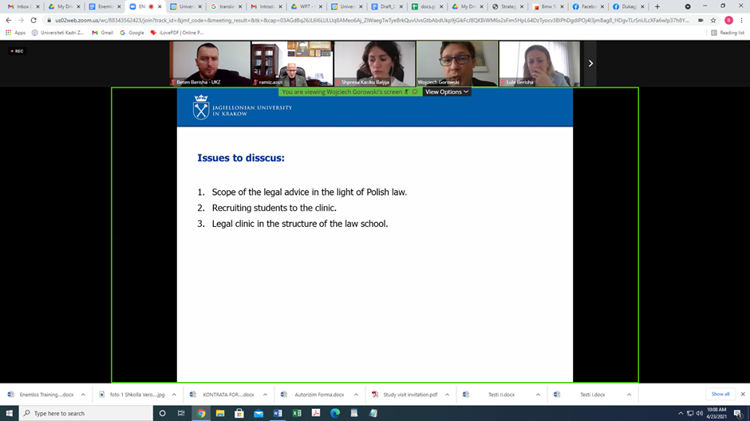
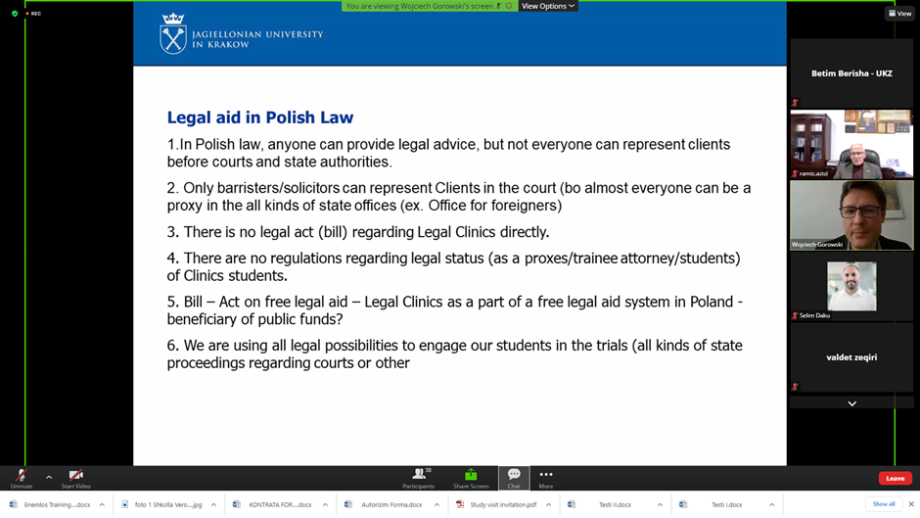

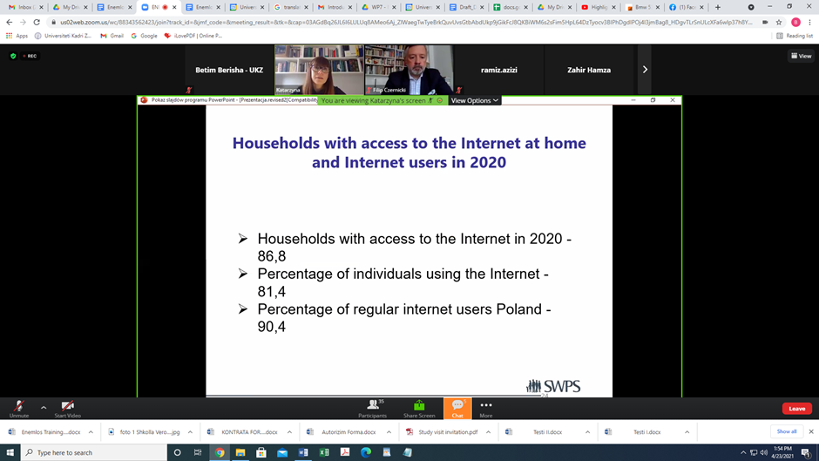

Useful links:
https://www.swps.pl/uslugi/poradnia-prawna
https://english.swps.pl/warsaw/faculty-of-law-in-warsaw/student-legal-services?_ga=2.87488408.1210246122.1616625895-977510682.1583518877

This report was compiled by:
Prof. Asoc. Dr. Dukagjin Leka
Mrs. Luljete Berisha
University “Kadri Zeka” in Gjilan

www.uni-gjilan.net

