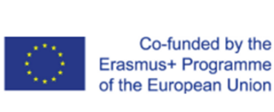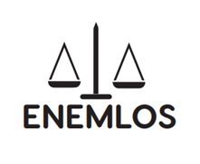
LEGAL CLINICS IN SERVICE OF VULNERABLE GROUPS: ENHANCING THE EMPLOYABILITY OF LAW STUDENTS THROUGH PRACTICAL EDUCATION
ENEMLOS

Report for the 1st day training in the framework of ENEMLOS Project
CLINICAL LEGAL EDUCATION IN POLAND - GENERAL INTRODUCTION

This training has been recorded by UKZ with permission of all partners and in the bottom of it you will find the link in share drive

10:00 – 12:00 Dr Filip Czernicki, Dr hab. Izabela Kraśnicka (The Polish Legal Clinics Foundation)
Introduction to the trainings

This training was opened by prof.Dukagjin Leka, from UKZ, who spoke for the role of the project and introduced partners from Kosovo. Then Prof. Filip, started his presentation with a summary of the Polish legal clinics activity and some statistical data Basic information on the Polish Legal Clinics Foundation activity. He stated that in Poland there are Poland 38 milion inhabitants and 27 law schools and 27 clinics in 17 cities with 318 supervisors, 1 219 students, 2 547 cases,4 – supervisor/student ratio 2 – cases/student ratio.
They presented the status of legal clinics and very few NGO based legal clinics in Poland.
Almost all of the legal clinics in Poland are recognized by the Universities as a part of the legal curriculum at our law schools (as one of the optional classes that are offered to the students).
Legal Clinics are present at every law school in Poland. Some of the legal clinics (Krakow, Warsaw, Bialystok, Lodz) gained a status of a chair or laboratory, which means that they became part of the university budget. All of the legal clinics that are based at the Universities get all the office costs covered, majority of the professor’s salaries are paid by the universities.

Continuing with polish legal clinics standards from Dr. Izabela: as Service is free of charge. Legal clinic assures the supervision of the Faculty’s workers over the clinic’s activity (one person may not directly supervise more than 16 students).Legal clinic assures confidence reg. its services and safety of the documents submitted by the clients. Legal clinic informs the client in written about the rules of the clinical services, in particular stating that: student is a person taking the case, student cannot refuse to give evidence or answer a question of any authorized organ, legal clinic does not take cases in which an advocate already participates, legal advice is given in written only. Legal clinic sets a qualifying procedure regarding their clients which is to assure that the client cannot afford payable legal advice.
Legal clinics sets, according to the proper rules of law, information system on the clients which is to guarantee minimal risk of the conflict of interests. Legal clinic is obligated to conclude an insurance contract on the liability for damages, the guarantee amount cannot be lower than 10.000 EURO.
Legal clinic runs a secretariat and submits yearly its statistics to the Polish Legal Clinics Foundation.
The client has a right to turn any comments on the given legal advice to the Legal Clinics Foundation.

During the presentation, they presented Legal clinics achievements, which are:
- The Foundation has the status of the public benefit organization.
- Won a distinctive prize of the Best Pro Publico Bono Civil Initiative contest.
- In 2013 received award from UNDP and European Social Fund for the Best Social Partnership of the year.
- ELSA Poland granted the Foundation title of „Legal Education Supporter”
in 2006 and 2007.
- For 18 years has organized annual Pro Bono Lawyer Contest.
- Granted legal clinics with material and financial means of the total value
of appr. 164 000 USD (financial) and over 816 000 USD (in-kind).
- Published first in Poland and in region textbook „The Legal Clinics. The Idea, Organization, Methodology” (available also in English and Chinese). By the time being we published 17 textbooks and manuals on clinical legal education.
- Organized 31 National Legal Clinics Conferences as well as several workshops.
- Actively participated in the creation of a strong clinical movement in Central and Eastern Europe and in the transforming countries including: Ukraine, Czech Republic, Moldova, Uzbekistan, China, Russia, Serbia, Belarus, and Georgia.
- In 2008 Centrum Pro Bono has been opened as a program which aims to connect pro bono legal aid offered by law firms with legal needs of the NGOs.

Questions and discussion

Then, the discussion was opened for all, where he responded in different questions and comments made by the participants.

12:00 – 13:00 Break

13:00 – 14:00 Dr hab. Barbara Namysłowska-Gabrysiak (Warsaw University Faculty of Law and Administration)
Clinical legal education methodology
After the break, we continued with the 2nd session of the day I of the training. Dr. Barbara stared her presentation about the clinical legal education in Warshaw clinic. Complex System of Practical Education at Warsaw Legal Clinic as: Compulsory Skills courses; Practical Elements in other Compulsory Courses; Elective Skills Courses; Moot Courts; Externships and Other Practical Courses

The Warshaw legal clinic are divided in 12 sections:
Civil law (I and II)
Labour law
Criminal law/anti-discrimination
Criminal law – convicts
Medical law (I and II)
Human Rights/refugees
Harm Reduction Programme (help for drug addicts and HIV carriers)
International Judicature
Administrative law
Programme for innocent persons

The main goal of these clinics are:
EDUCATIONAL GOAL: improve the quality of teaching for students at the FLA by incorporating the practical application of law into the programme of studies and introducing new methods of teaching,
WORK PRO PUBLICO BONO: provide high quality, free legal advice to those with a low income status, Increase the social awareness of law students, Promote the idea of pro bono work among future lawyers, increasing the level of legal knowledge and legal awareness within society.

These clinics, programme includes: The clinical programme developed for students includes:
Psychological workshop training (compulsory skills course at the beginning of academic year);
General seminars which are every week and with the participation of all students and Work in sections (section seminars) by: Curriculum for the academic year and Curriculum for each classes. The methods of section seminars are: Snowball; Each one teach one; SWOT; Brainstorming and mini-simulations.
Also, Dr. Brbara talked about the client interview. What does a typical customer service look like? (in Warsaw Legal Clinic). A client, after obtaining information about the Clinic, most often from the media, brochures or acquaintances, calls or comes to the Office to make an appointment.
A pair of student interviews the Client at the agreed time, determines the factual circumstances of the case and obtains copies of documents, if needed.
Students prepare a draft of the opinion and present it at a seminar in a given section.
After the coordinator accepts the legal opinion, the students prepare the final version of the opinion which they present to the client or prepare drafts of appropriate statements of claim.

The duration of the whole procedure depends on the complexity of the case, on average it takes 2-3 weeks, except cases pertaining to refugees, where the case is monitored after it is initiated and until it is resolved.
How to teach the students to interview the client?- Presentation; client interview simulation and Video simulation – online classes. You must schedule of all meetings with the clients in Legal Clinic
Student are looking on a relevant area of law or legal institution. Students revise information on a relevant area of law or legal institution. Then, you have to conduct the Interview (Conversation):
Conversation is initiated (5-10 minutes); Conversation proper (at least 30 minutes);Meeting is concluded (10 minutes), all these with Active method: work in group (4 students).
After these, you must arrange Post-Interview Actions as: Establish the factual status; Outline the legal problem(s) with Active method: Snow ball (next slide)
During the interviews and conversation, you can face to some problems as: Time shortage; Client that cannot be helped; difficult client; Different active method
In the section of Legal opinion, you must teach the students how to prepare the legal opinion. This is the most important part, which includes: Establishment and presentation of factual circumstances
Identification and outline of a legal issue/s; Analysis of legal norms, rules, circumstances, including possible legal solutions; Presentation of actions taken by the law

Establishment and presentation of
- Factual circumstances passes in these phases: Proper establishment of factual circumstances; Verification of the client’s version; Verification of documentation;
- Inappropriate factual circumstances: ONLY Client’s version, Subjective, incomplete, not based on documents, too short, narrow.
You must follow these questions:
- Is the opinion concise and understandable?
- Is the description of factual circumstances coherent and credible?
- Is the style and setup the same in the whole text?
- Does the text and graphic design allow for an instant understanding of the content and fast overview of the document?
- Is the table of contents clear, not overloaded and inserted at the beginning of the document?
- Is the structure of the opinion clear? Are there any helpful subheadings and underlinings reflecting the content and making it useful for both those who want to read the whole text and those who want to carefully study a particular issue?
- Is the opinion objective in all aspects? Are the realistic and legal goals of the client and counsel properly identified?
- Are the factual data and opinions differentiated?
- Are the various opinions and comments presented in a balanced manner?
- Are the used sources reliable and, as far as possible, original and not secondary?
- Are the sources correctly quoted?
- Were copyrights observed when quoting materials?
- Were the suitability and deficiencies of the used sources properly assessed?
- Does the summary constitute an independent discussion of the issues in question and is it understandable without additional footnotes?
- Did at least one person other than the author carefully read the whole opinion to check its content, construction and presentation? Were all the necessary corrections made?
- Was the legal opinion prepared in accordance with all proper grammar and spelling rules and was correct punctuation used in the opinion?

Next phase if preparing the legal paper. Preparing legal papers taking a case to ECtHR: Each one teach one Rules: Knowledge – groups
Lawyer must have skills in order to know the situation better, they must follow active methods such as: MOOT COURT; MOCK TRIAL; MINI-SIMULATIONS; WORKSHOPS: snowball, each one teach one, SWOT, brainstorming; Experiences of the Warsaw Legal Clinic.
Mock trial- Moot court includes: Simulation of a hearing before a court of first instance (mock trial);
Simulation of a hearing before a court of second instance (moot court); Simulations of court sessions (examples).
Moot courts: Goals (hearing before a court of first instance; hearing before a court of second instance)
Materials; Script preparation; Summary
Mini simulations: Topics covered in classes; Goals; Materials; Script preparation and Summary
Rules: do not evaluate – do not judge – do not shape; each as many ideas as possible and variety increases quality
Opened discussion

14:00 – 15:00 Dr Przemysław Kubiak (Lodz University Faculty of Law and Administration)
Teaching soft skills in clinical legal education

In the last session of day 1, prof. Przemyslaw presented soft skills in legal education. He asked all participants what they think about the soft skill and how they describe them. Some participants expressed their opinion about them. Then he continued his interactive presentation.
Also, he asked from participants to tell why do we teach them (soft skills)? He showed three points: knowledge – skills – values; practice by doing; one-time workshops, systematic meetings, mentoring

Entire presentation was interactive. He also showed a short video about the crime scene.

List of participants:
https://docs.google.com/document/d/1TjnYoEAH1PEvFj_34XQUZEmwXXYI-6VX/edit

Name | Institution | Position | Signature | Signature to publish photos
Luljete Berisha | UKZ | IRO | yes | yes
Sabiha Shala | UHZ | Vice Rec/Project Coordinator for UHZ | yes | yes
Dukagjin Leka | UKZ | Vice Rector for IC | yes | yes
Petrit Hajdari | UHZ | Academic Staff-Part time | yes | yes
Selim Daku | UKZ | Professor | yes | yes
Betim Berisha | UKZ | IRO | yes | yes
Durim Hoxha | UHZ | Academic Office | yes | yes
Fatime Bamja | UHZ | Teaching Assistant | yes | yes
Rilind Sermaxhaj | BC | Judge | yes | yes
Barbara Nmayslowska | Warsaw University | Professor | yes | yes
Shpresa Kaciku Baljija | UKZ | Academic Staff | yes | yes
Qerkin Berisha | UP | Professor | yes | yes
Qendres Shala | UHZ | Teaching Assistant-Part Time | yes | yes
Petrit Nimani | UHZ | Dean-Law Faculty | yes | yes
Gjylbehare Murati | UHZ | Academic staff | yes | yes
Zenel Hasanaj | Free Legal Aid Office in Peja | Legal Officer | yes | yes
Albion Rexhepaj | UHZ | Master student | yes | yes
Dorentina Zekaj | UHZ | Intern (alumni) | yes | yes
Verona Feri | UHZ | Master Student | yes | yes
Detrina Alishani Sopi | UKZ | Teaching assistant-Full time | yes | yes
Liza Rexhepi | UKZ | Teaching assistant-Part Time | yes | yes
Drejtim Berisha | UP | Alumni student | yes | yes
Urtak Hamiti | UKZ | Professor | yes | yes
Berat Dermaku | UKZ | Teaching assistant-part time | yes | yes
Egzon Lajqi | Bar Association | Lawyer | yes | yes
Dr hab. Izabela Kraśnicka | PLCF | Dr | yes | yes
Dr Filip Czernicki | PLCF | Dr | yes | yes
Asdren Saramati |  | Teaching
Dr Przemysław Kubiak | (Lodz University Faculty of Law and Administration | Dr | yes | yes
Aferdita Bislimi | KBA | Layer | yes | yes
Fatmire Krasniqi | UKZ | Professor | yes | yes
Fadil Osmani | UKZ | Professor | yes | yes
Pajtesa Fera | Bar Association | Lawyer | yes | yes
Pajtes Boshnjaku | Bar Association | Lawyer | yes | yes
Valdet Zeqiri | Bar Association | Lawyer | yes | yes
Egzon Lajçi | Bar Association | Lawyer | yes | yes
Asdren Saramati | Bar Association | Lawyer | yes | yes
Zahir Hamza | Bar Association | Lawyer | yes | yes
Arber Guta | Bar Association | Lawyer | yes | yes
Erblina Kresniqi | Bar Association | Lawyer | yes | yes
Petrit Lladrovci | Bar Association | Lawyer | yes | yes
Albulena Ukimeraj | Bar Association | Lawyer | yes | yes
Besim Abdullahu | Bar Association | Lawyer | yes | yes
Biljana Djuricin | MU | coordinator | yes | yes
Dr Przemysław Kubiak | University of Lodz | Professor | yes | yes
Bedri Peci | UP | Professor | Yes | Yes
Mirlinda Batalli | UP | Professor | Yes | YES

https://m.facebook.com/story.php?story_fbid=10225690343709181&id=1347564035
https://m.facebook.com/story.php?story_fbid=10158466514608978&id=617073977
https://m.facebook.com/story.php?story_fbid=4144499495613008&id=100001589967153
https://m.facebook.com/story.php?story_fbid=10158466514608978&id=617073977

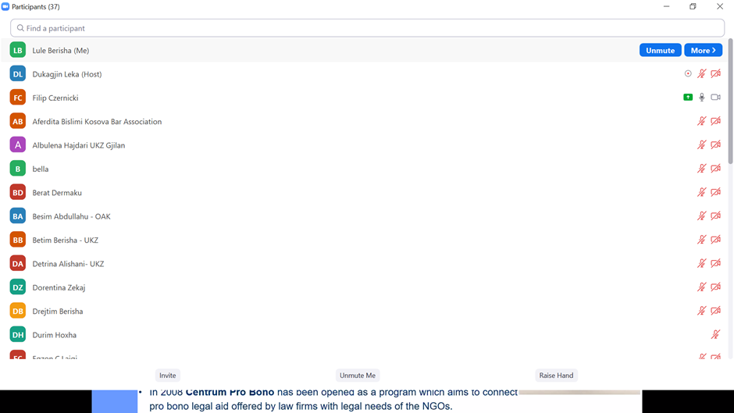

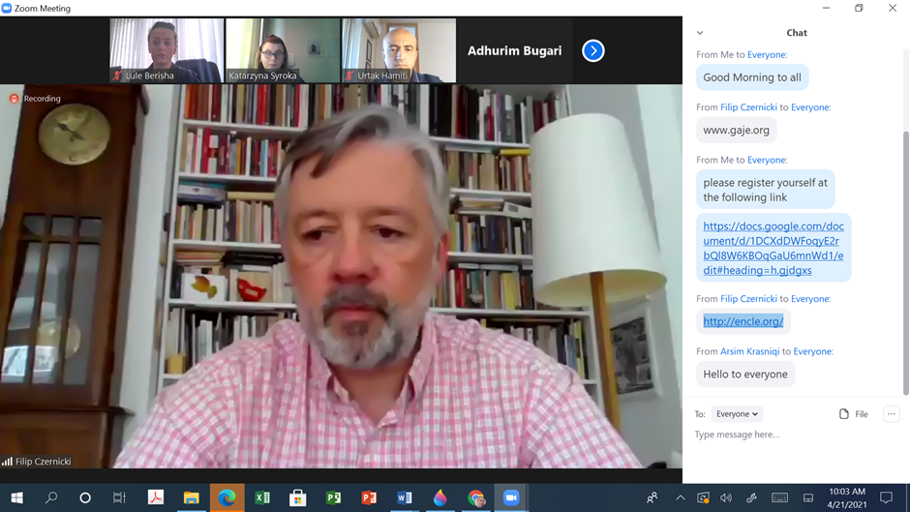

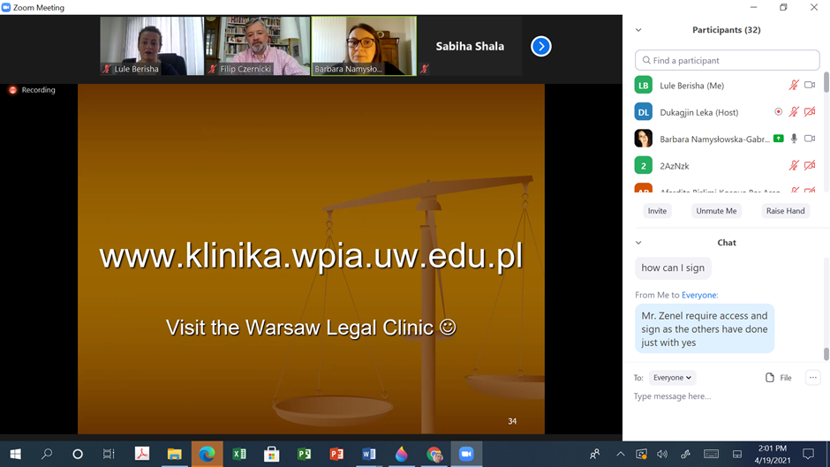

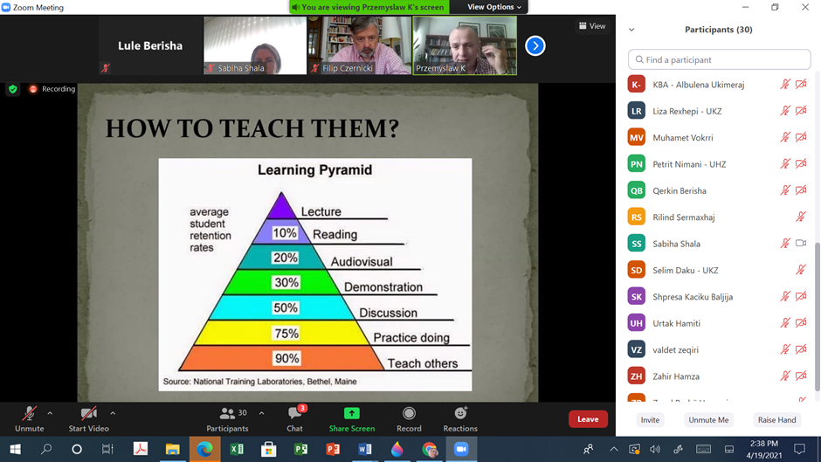

Useful links shared during the 1st day of the training in chat box:
http://www.fupp.org.pl/en/legal-clinics/standards
http://www.fupp.org.pl/en/
www.gaje.org
http://encle.org/

This report was compiled by:
Prof. Asoc. Dr. Dukagjin Leka
Mrs. Luljete Berisha
University “Kadri Zeka” in Gjilan

www.uni-gjilan.net

