Marija Radović Popović
Date of birth: 04.08.1989.
Address: Svetozara Markovića 16, 81000 Podgorica, Montenegro
Telephone: +382 (0)67 285628
Email: radovicmara89@gmail.com
marija.radovic@sudstvo.me

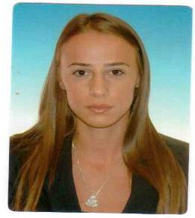

Education

- Entrepreneurship economy (major - Insurance) University of Donja Gorica, 2016 - 2017
MA degree (expected in September)

- Faculty of Law, University of Montenegro 2008-2012
Specialist of Law (major - Judiciary)

Training

- Workshop on Enforcement of International Sales Contracts, 2019
- Regional Conference “The Obligation to Execute Decisions of the European Court of Human Rights”, 2019
- Regional Forum on Judicial Cooperation in Criminal Matters, 2018
- Workshop on Administrative Justice, 2018
- Seminar on European Convention on Human Rights (Article 6), 2018
- Seminar on Free Access to Information, 2018
- Training on Code of Ethics, 2017
- Training on Prohibition of Discrimination, 2016
- Training on European Convention on Human Rights, 2015
- Bar Exam, 2014
- State Exam, 2013

Work experience

Supreme Court of Montenegro, December 2019 – ongoing
• Legal advisor
Appellate Court of Montenegro, October 2016 – December 2019
• Legal advisor
• PR
• PRIS Administrator
• Answering the requests concerning free access to information

Office of Appeals Montenegro, July 2016- October 2016
• Legal advisor

Appellate Court of Montenegro and Basic Court in Podgorica, October 2012 – July 2016
• Trainee

Environment Protection Agency of Montenegro, January 2012 - May 2012
• Program assistant in the Aarhus Centre

Centre for Monitoring and Research (CEMI), January 2009 – April 2011
• Part-time job as assistant in various projects

Skills
• Languages:
o English (C1)
o French (DELF B1)
• Computer skills (ECDL level)
• Good communication skills
• Teamwork oriented
• Ability to adapt to new environments

References
Available on request

